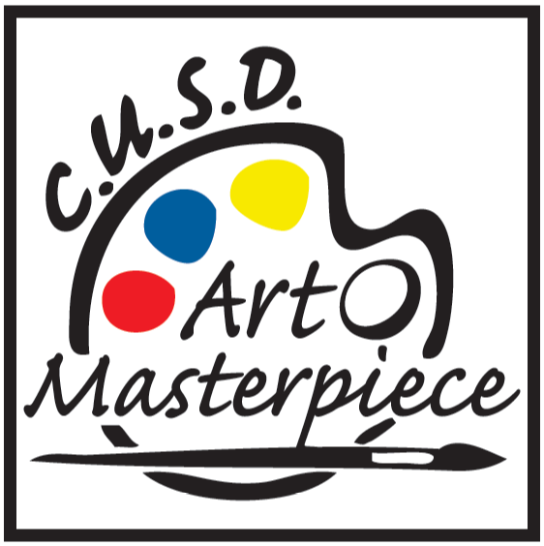 | Volunteer Information

Art Masterpiece is a successful, volunteer-based,
art enrichment and education program.

We depend on VOLUNTEERS to share fun art lessons and projects with our elementary school students throughout the school year.

No teaching experience necessary
NEW! - All lessons are presented on Google Slides

No art experience necessary
All art projects have step-by-step instructions

Only 6 (one-hour) lessons are taught per year
15 minutes for set up prior to the lesson and 15 minutes clean-up afterwards

Serve in your own child’s classroom
Get to know your child’s teacher and peers

We provide training, lessons, projects, and all art supplies

For more information, please contact:

Sharon Newquist sharonnewquist123@gmail.com
Talisha Heiden modernmommyboutique@gmail.com
Tori Duarte toripug801@gmail.com

